# Guidelines for presenting results from SIBER

This is intended as guidance only for presenting some of the results from the SIBER routines within the R package SIAR. There is no, single way to present the results, especially given the diversity of questions that can be asked, but these are at least appropriate and suitable in many cases. These results accompany the demonstration script “demo.SEA_v3.r” which can be downloaded from <http://www.tcd.ie/Zoology/research/research/theoretical/siar.php>

# Results

The raw isotopic data for 3 groups of observations are depicted in Figure 1 along with their respective convex hulls and their standard ellipses (SEAc for small sample size correction) based on maximum likelihood estimates. The sizes of the ellipses vary significantly among groups (Figure 2) with pairwise tests indicating that G2 is larger than G1 (with probability = 0.99), G2 is larger than G3 (with probability = 0.002) but G3 not larger than G1 (probability = 0.74).

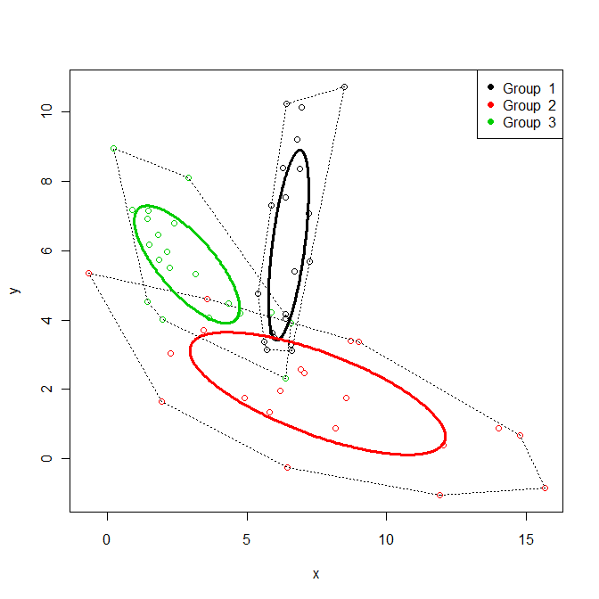

**Figure 1.** Variation in isotope data for the 3 groups with their respective convex hulls and small sample-size corrected standard ellipses (SEAc).

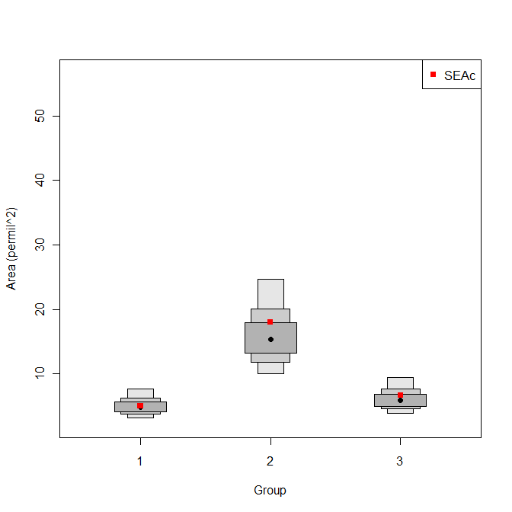

**Figure 2.** The posterior estimates of the standard ellipse areas (SEAB) for the 3 groups. The boxes represent the 95, 75 and 50% credible intervals in ascending order of size, with the mode indicated by the black circles. The maximum likelihood estimate for the corresponding SEAc as depicted in Figure 1 is indicated by the red squares.